FACULTY EVALUATION
Programme Name: SBVP ALUMNI MASTERCLASS - SCALE Module I Online Kenya (20th April 2026 - 24th April 2026)
Session: Reflect on Vision and Mission || Reflect on charism || Identify alignment to social enterprise
Faculty Name: Loise Wanjiru Oburu
No. of Respondents: 16
No. of Participants: 16
Evaluation Parameter | (%) Individual Score | (%) Programme Average
Punctuality (Commencement and Completion of Sessions) | 96 | 96
How well do you understand the core concepts presented? | 92 | 90
Rate your confidence in applying the new skills learnt | 85 | 84
Degree of Faculty preparedness for the sessions | 94 | 94
Content and methodology of the program | 92 | 93
Quality of class and group discussions | 90 | 90
The information presented in the course is relevant to my work (ministry) | 92 | 93
Average scores | 92 | 91

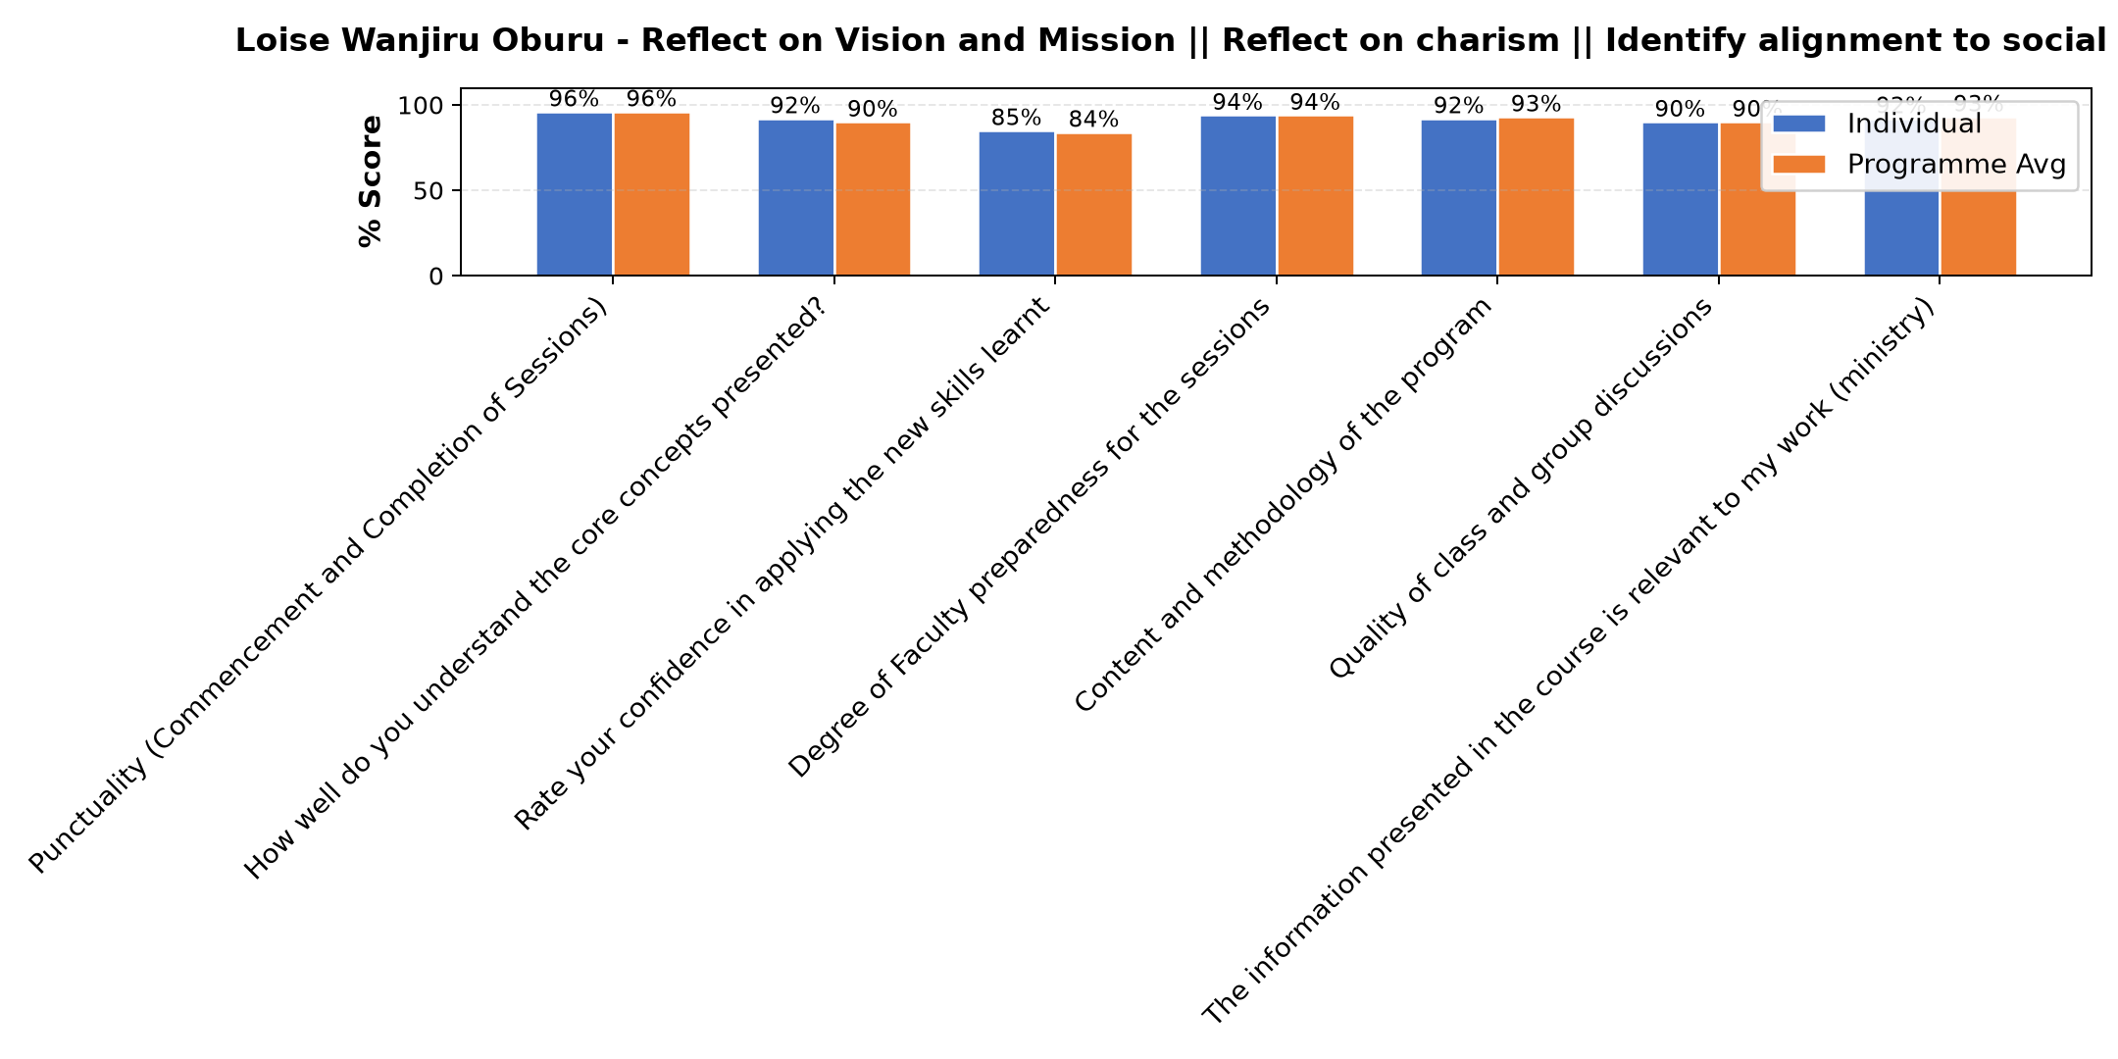

Comments & Feedback
- • Inadequate resources
- • Threats from the competitors
- • Sufficient funds for mplement action.
- • Lack of readily available finances to speed up the process
- • I would love to implement it but time is a barrier in that I will have to wait till end of the year when learners are away for 2 months
- • Interference from the leaders
- • Not that I know of
- • Proper action plan
- • Luck of define specific measurable of projects and financial problem.
- • Her approach is good tho so much on money making than evangelisation
- • Limited funds
- • Support
- • Resources
SUBMITTED THROUGH:
SBS Evaluation Automation System

